Cricket Player Performance Tracking
Application : CRICKSTATS
A Project Report Submitted by:
ZAIBA FATHIMA K.P - Reg No. 34623U23044
MASIRA FATHIMA S - Reg No. 34623U23023
MUZAKKIRA K - Reg No. 34623U23027
MuBASHIRA KOWNAINE S - Reg No. 34623U2326

in partial fulfillment for the award of the degree of

Bachelor of Science
in
Information System Management

M.M.E.S WOMEN’S ARTS AND SCIENCE COLLEGE
Accredited by NAAC with B+ Grade, CGPA 2.74 out of 4 Hakeem Nagar – Melvisharam
Affiliated to Thiruvalluvar University, Serkkadu, Vellore – 632 115

March 2026

Cricket Player Performance Tracking
Application : CRICKSTATS

- Introduction

CRICKSTATS is a cloud-based application designed to track and analyze cricket player performance on a match-by-match basis. The system is built on the Salesforce platform and helps manage player statistics, match data, and performance analysis in a centralized system.
The application enables coaches, analysts, and team managers to store player data, record match statistics, and generate reports for better decision-making.

- Project Objective
The main objectives of this project are:
To create a centralized system for managing cricket player statistics
To track player performance for each match
To provide analytics and reports for performance analysis
To automate data management using Salesforce features

- Problem Statement
In many cricket teams, player statistics are recorded manually in spreadsheets or files. This creates several issues:
Difficulty in tracking player performance
Data inconsistency and errors
Time-consuming record management
Lack of real-time analytics
CRICKSTATS solves these problems by providing a centralized cloud-based performance tracking system.

4. Technologies Used
Layer
Technology
Platform
Salesforce
Interface
Lightning UI
Automation
Salesforce Flow
Database
Salesforce Objects
Analytics
Reports & Dashboards

5. System Architecture
The CRICKSTATS application consists of the following layers:
Presentation Layer – Lightning User Interface
Application Layer – Automation using Flows
Data Layer – Custom Objects and Fields
Analytics Layer – Reports and Dashboards

6. Project Modules
The system contains the following main modules:
Player Management
Stores player details such as name, team, role, nationality, and batting style.
Match Performance Tracking
Records match-by-match performance including runs scored, balls faced, wickets taken, and overs bowled.
Reporting & Analytics
Generates reports and dashboards to analyze player performance.
Automation
Uses Salesforce Flows to automate data processing and improve efficiency.

- Project Development Steps
Milestone 1: Salesforce Developer Account Creation
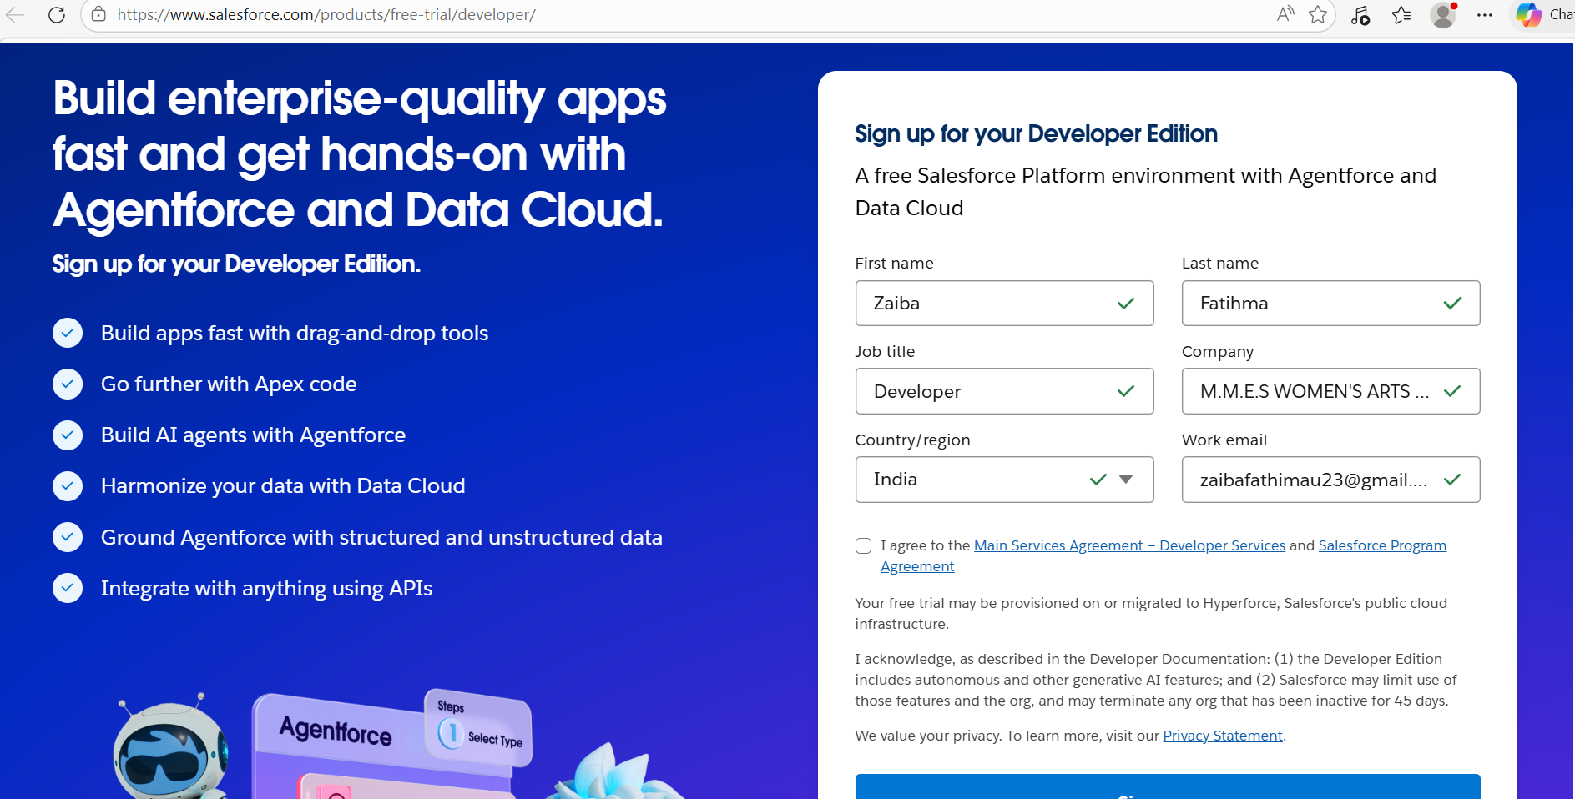

Salesforce Developer Account Home Page
Figure 1: Salesforce Developer Account Setup Page
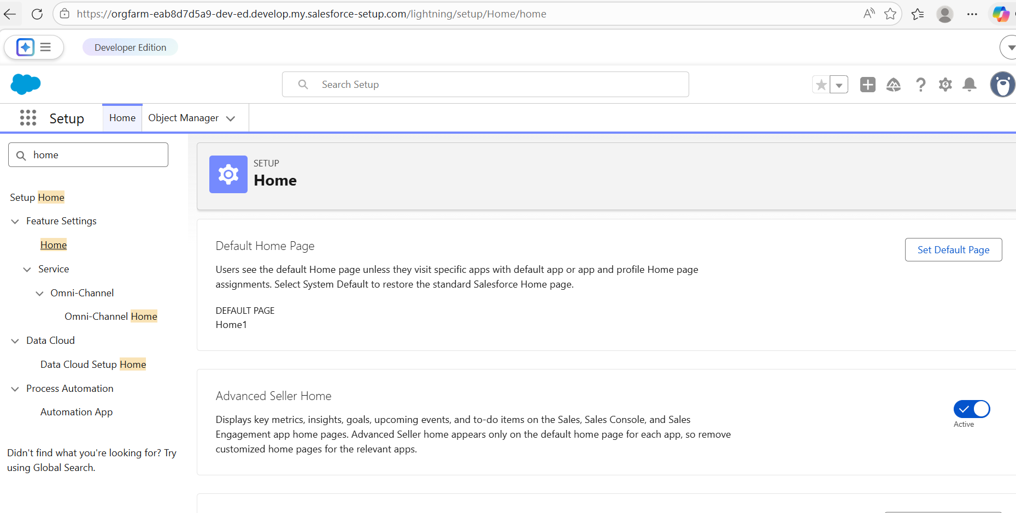

Milestone 2: Object Creation
Activity 1 – Player Object
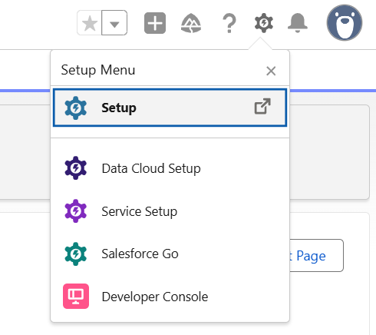

Milestone 3 – Tabs
Customer tab creation
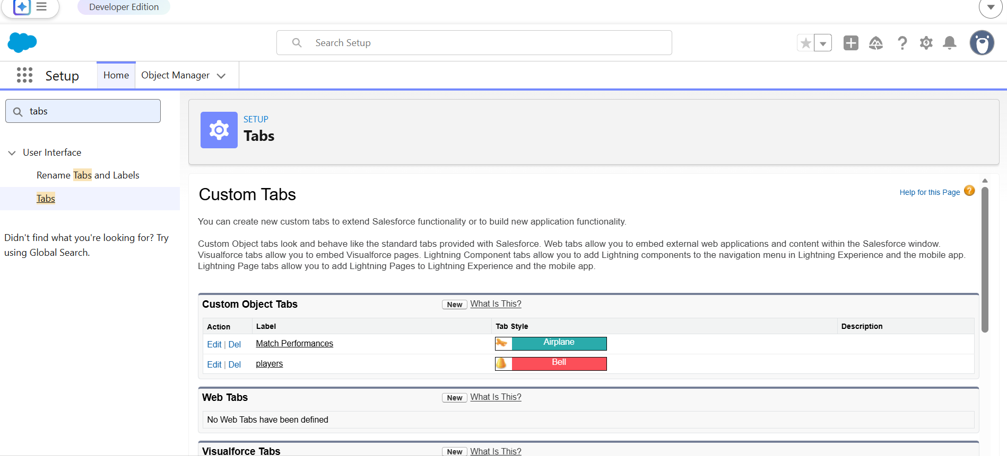

Milestone 4 – Lightning App
CRICKSTATS Lightning App interface

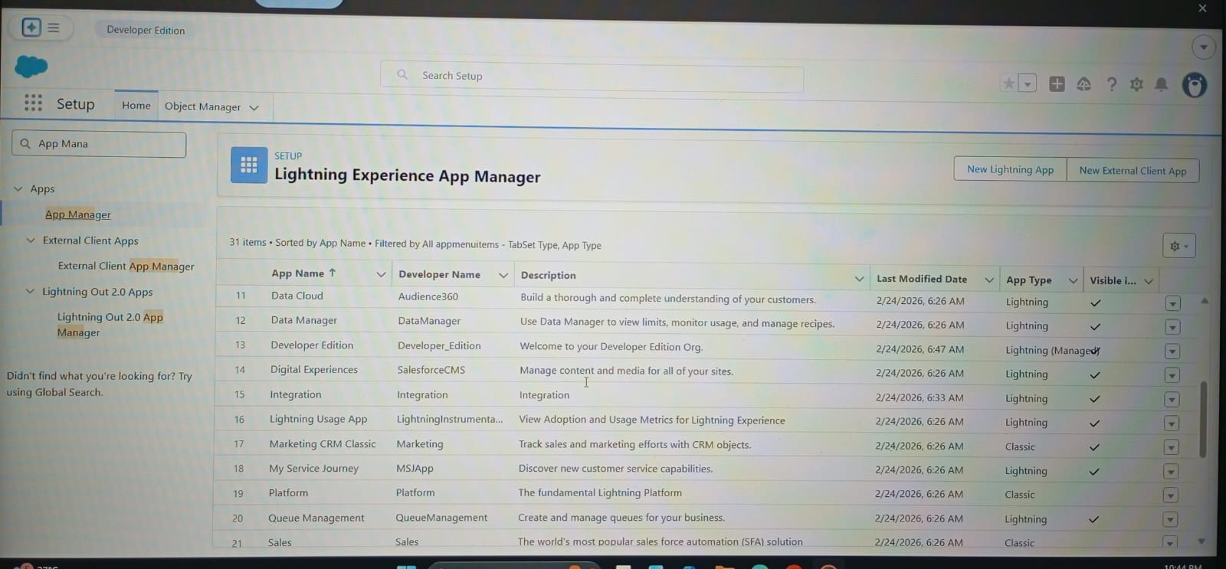

Navigation item
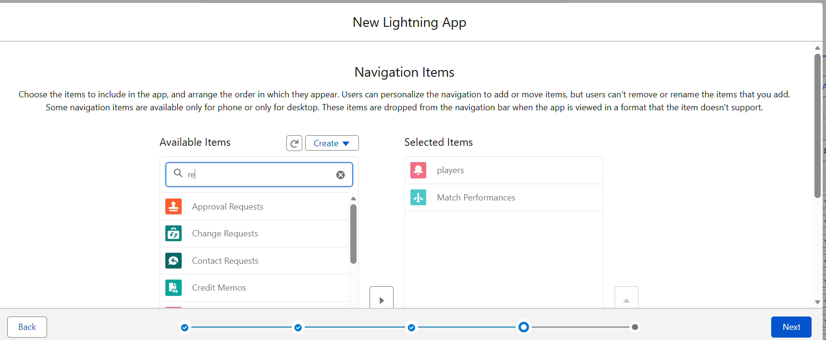

User Profils

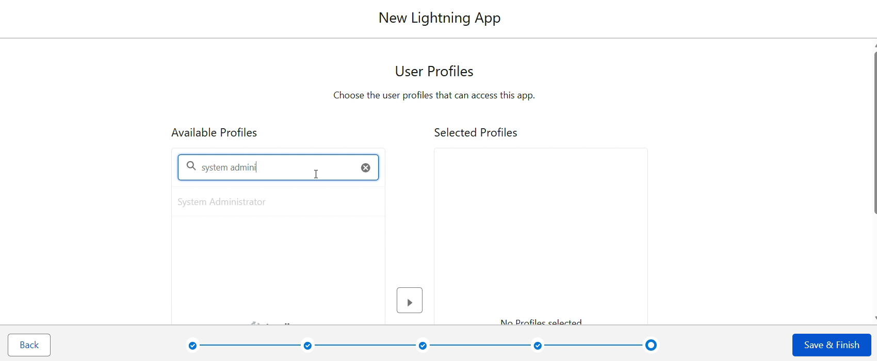

Milestone 5 – Fields & Relationships
Player Fields
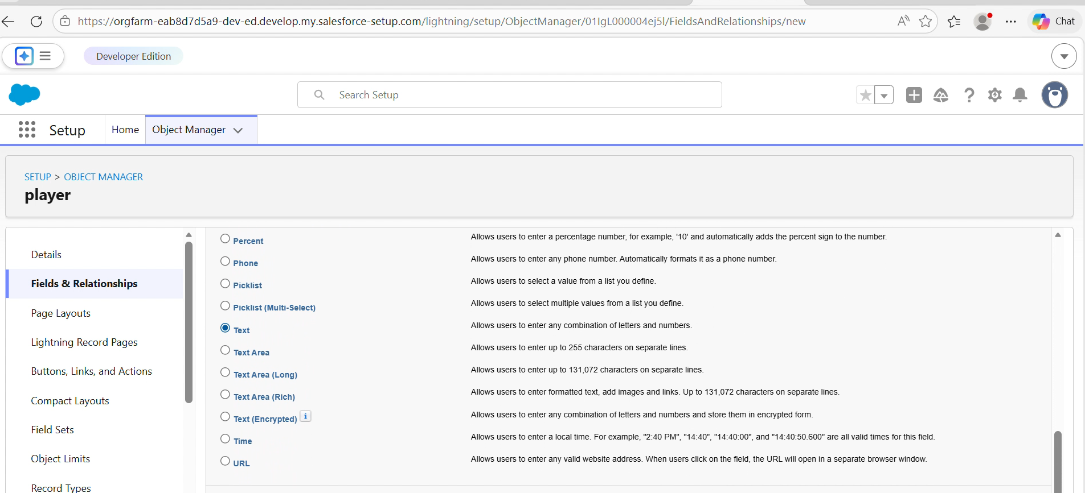

Milestone 6 – Roll-Up Summary

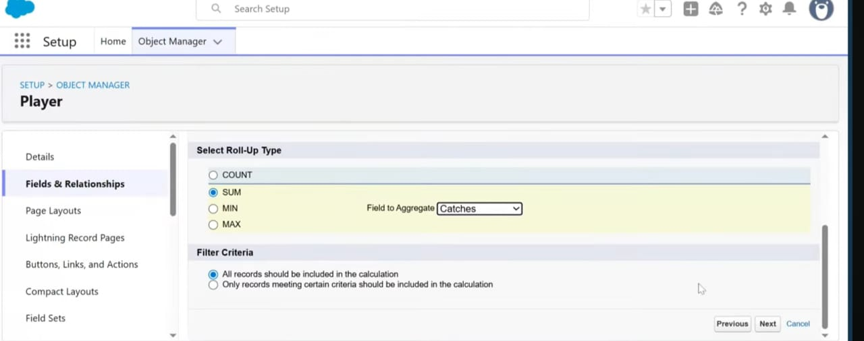

Milestone 7 – Flows
Screen Flow
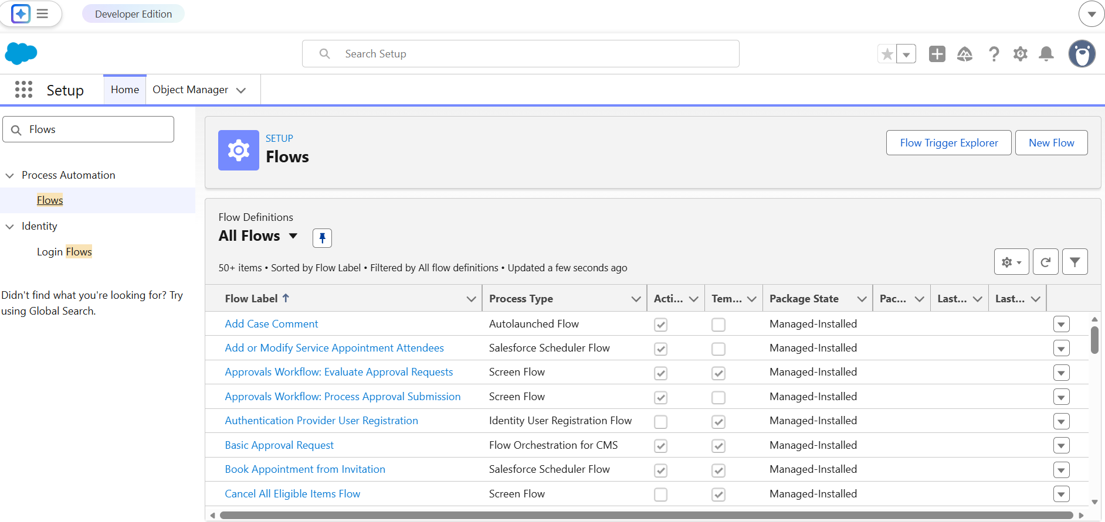

Screen Flow Builder
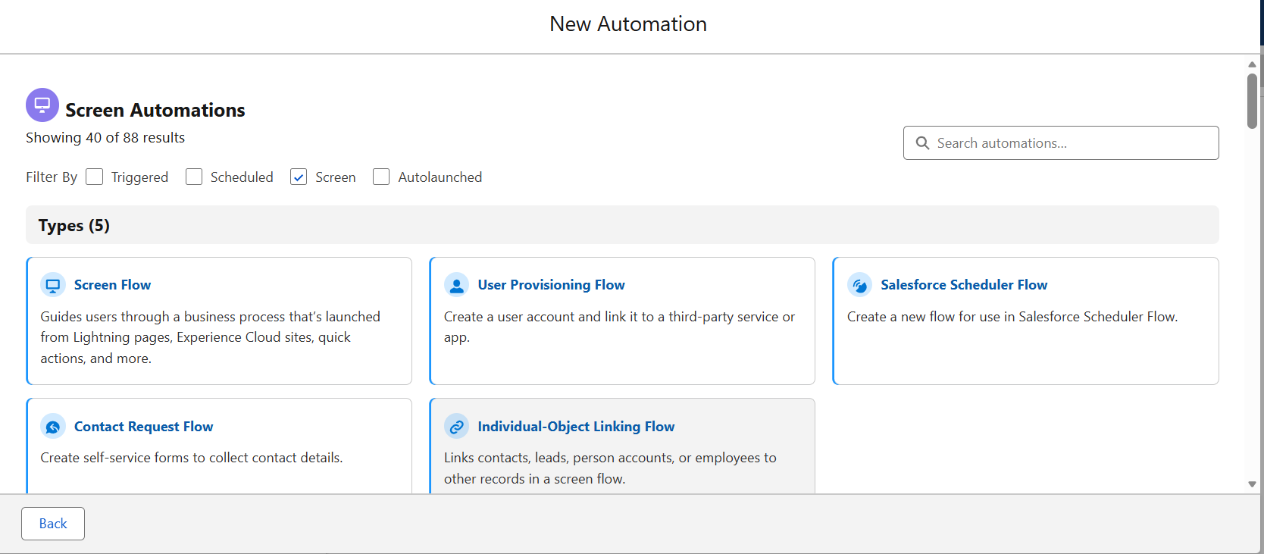

Home page with Player Flow
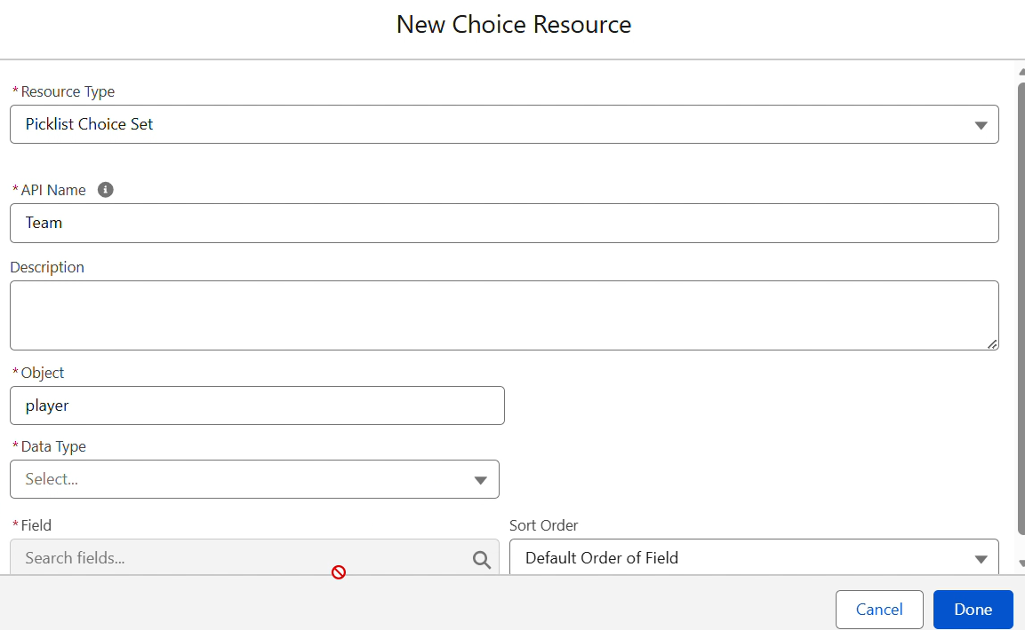
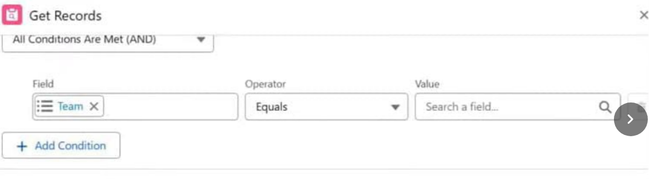

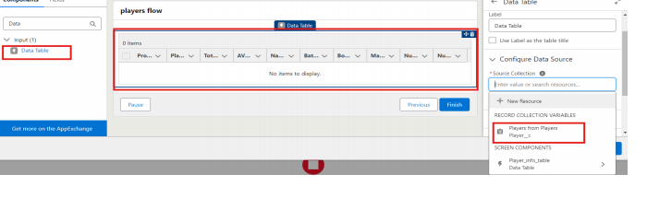

Flows
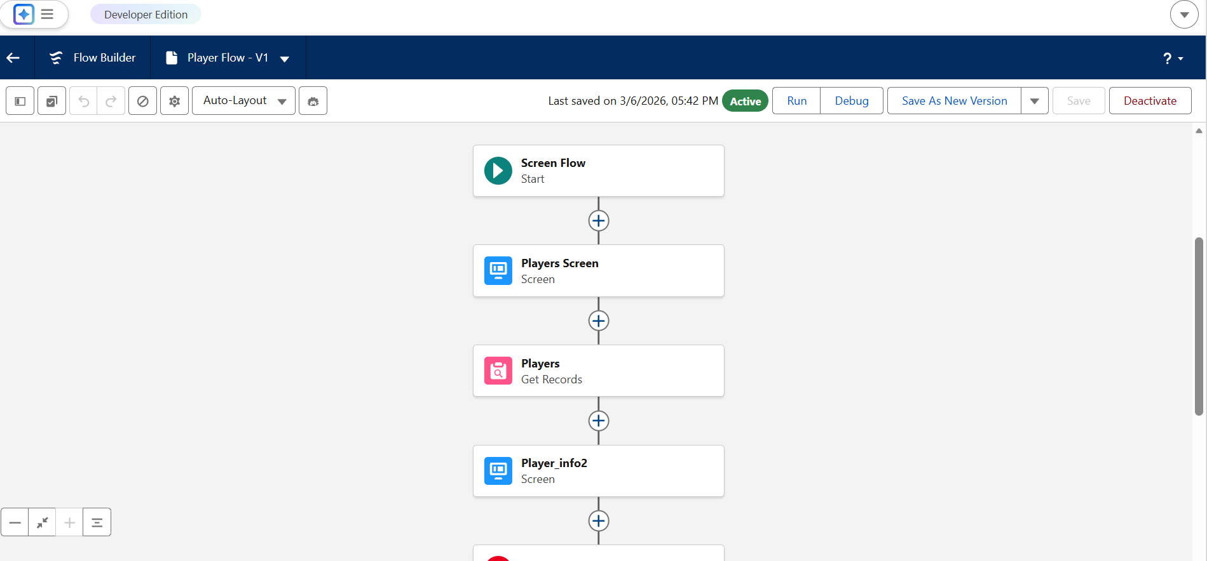

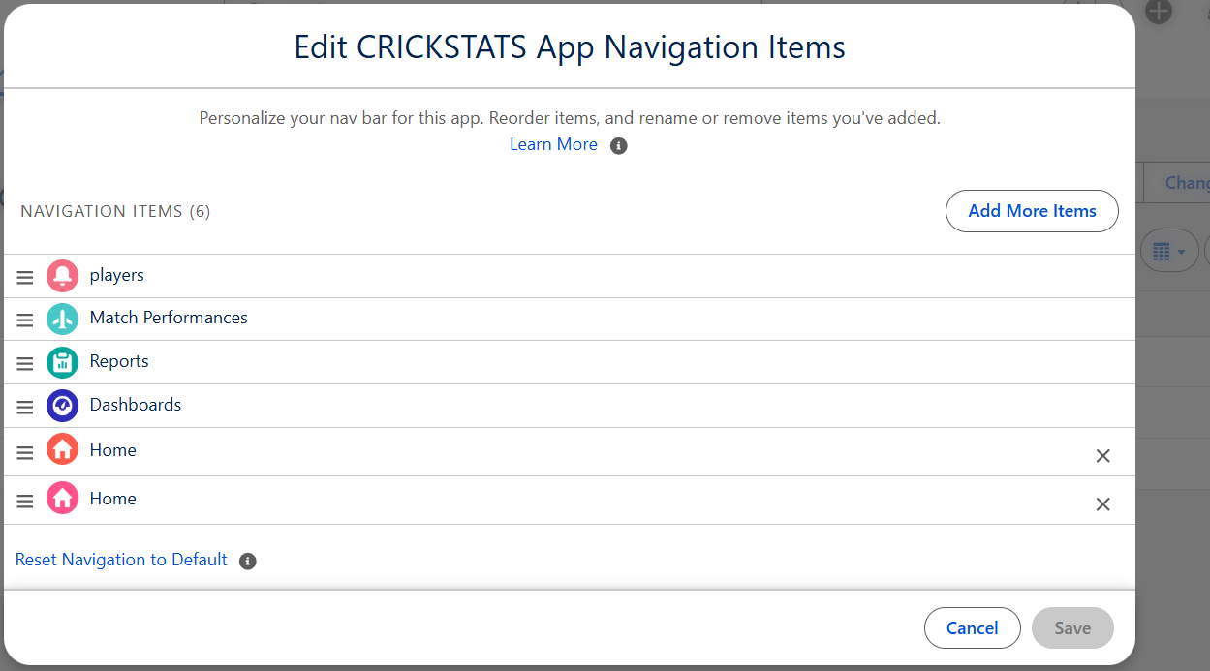
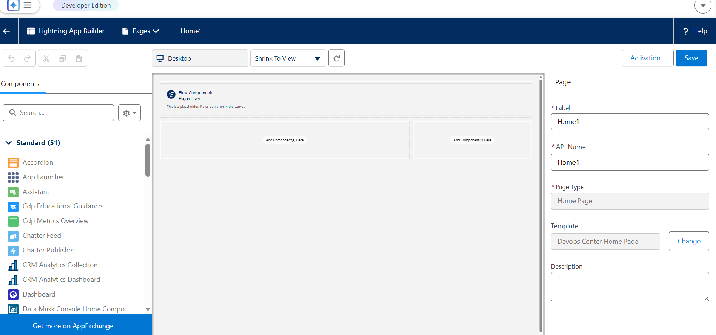

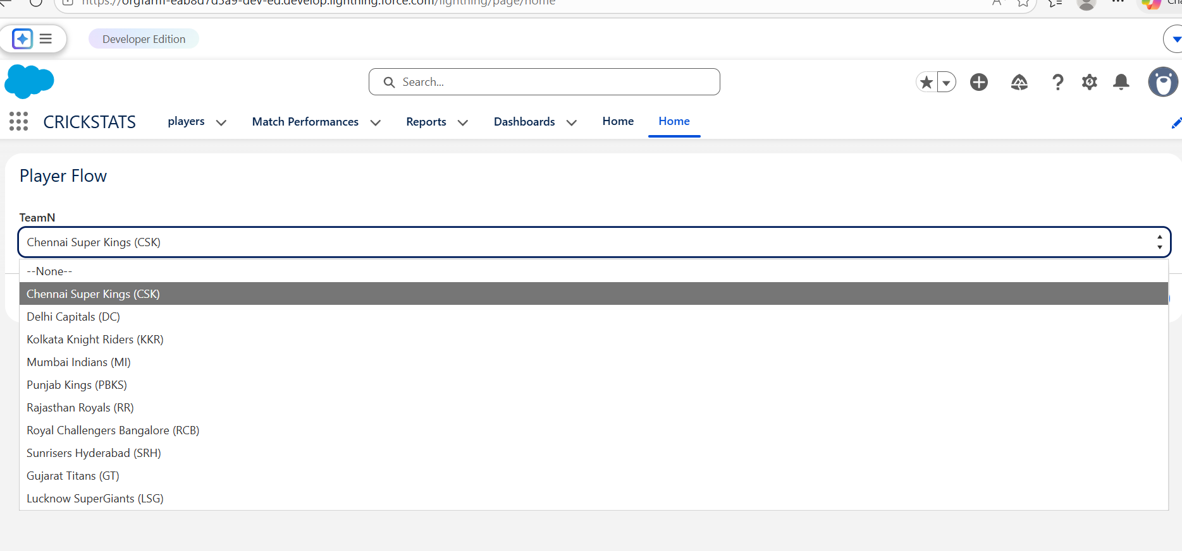

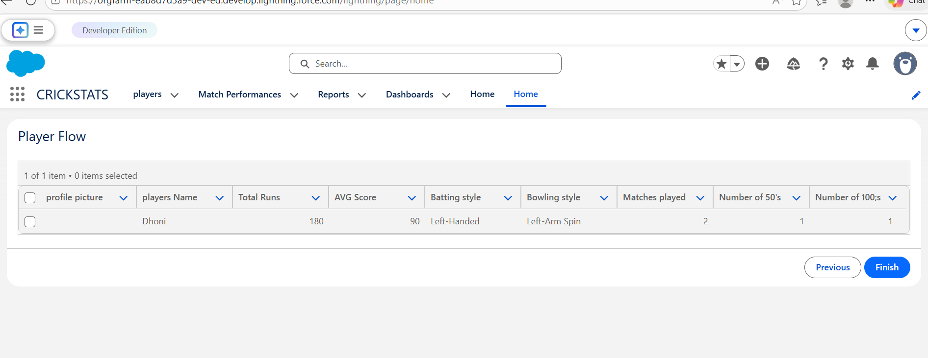

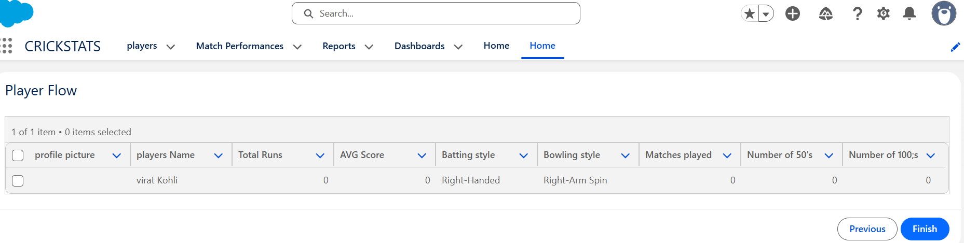
- Key Features
Centralized database for player records
Match-by-match performance tracking
Automatic calculation of statistics
Interactive dashboards and reports
Secure cloud-based access

9. Testing
The system was tested to ensure proper functionality.
Testing included:
Creating player records
Entering match performance data
Verifying roll-up summary calculations
Testing automation flows
Checking report generation
The application successfully generated accurate statistics and reports.

10. Advantages
Centralized performance tracking system
Easy access to player statistics
Automated calculations and analytics
Secure cloud storage
Improved decision-making for team management

11. Limitations
Requires internet connection
Depends on Salesforce platform
Limited offline functionality

12. Future Scope
Future improvements may include:
Mobile application integration
AI-based player performance prediction
Player ranking system
Multi-team and multi-league support

13. Conclusion
The CRICKSTATS application successfully demonstrates how Salesforce can be used to build a cloud-based performance tracking system. The project automates player data management, improves reporting accuracy, and supports better decision-making in cricket team management.

14. References
Salesforce Documentation
CRM Application Development Resources
Cricket Statistics Management Concepts

